PLEXTALK Linio Pocket Tutorial
- Network Folder -

Shinano Kenshi Co., Ltd. has the right to change the content on this tutorial without prior notice.

Table of Contents

1 What you can do with the Network Folder function 1
2 Set LAN manager authentication level of windows PC 1
3 Configure the network setting of your Linio Pocket 3
4 Start Network Folder 4
5 Log on to the Network Folder at your computer 4

What you can do with the Network Folder function

By using the Network Folder function, your personal computer can access the SD card in the PLEXTALK Linio Pocket as a network shared folder via your wireless LAN network.

Set LAN manager authentication level of windows PC

* If you use Windows XP or 2000 on your computer, Please skip this section.

- Download the ‘PLEXTALK Transfer’ software from the PLEXTALK web site and install it on your computer.
- Run the ‘PLEXTALK Transfer’. After the main screen appears, select ‘Network’ - ‘Network Configuration’ on the menu.
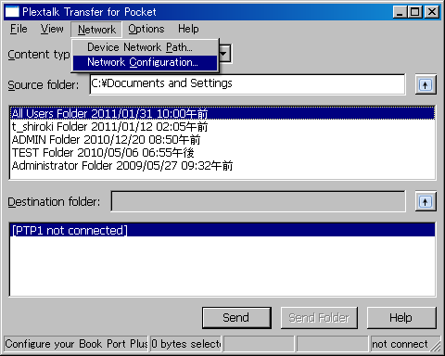

- Select the ‘Local Security Setting’ tab of ‘PLEXTALK setting utility’ dialog box.
- Press the ‘Start security setting’ button. The ‘Local Security Setting’ dialog box will appear.
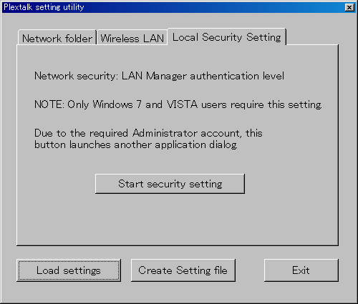

- Select “Send NTLM response only”. Press the OK button.
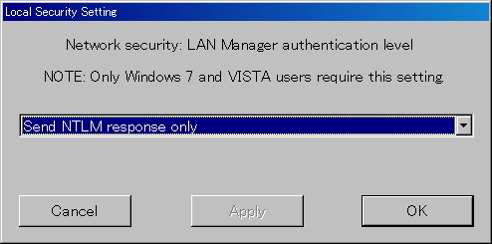

- You will see a confirmation message box. Press ‘OK’ to confirm.
- You need to restart your computer to make your computer apply this new security setting. The Utility will ask you confirm to restart your computer. Press ‘Yes’ to restart.

Configure the network setting of your Linio Pocket

Note: First obtain the information of your home wireless system or an office wireless system from your IT department.

- Enable the network device on your Linio Pocket. First press the Menu Key and go to “System settings”- “Network settings”- “Enable or disable network device” option. Select ‘Enable’ by the Right or Left Key and press the Down Key. The menu will automatically close when the network device becomes enabled.
Note: If your Linio Pocket is already configured for your network, it will automatically connect. Skip to section 4.
- Search available networks around your Linio Pocket. First press the Menu Key and go to “System settings”- “Network settings”- “Wireless network settings” – “Available wireless network” option. When you press the Down Key, your Linio Pocket will start searching.
- When available networks are listed, select the wireless network you want to connect to If not configured for your selected network, follow steps 4 and 5.
- Input network configurations. Your Linio Pocket will ask you for Security mode, Password, Stealth setting, DHCP and IP address, and Proxy server.
Note: You have an option to configure those network settings using the “Network Configuration” tab of the “PLEXTALK Transfer” software. For more information, see the “Help” option of the software.

Security mode: | Select the security mode that is set on the access point of the network.
Password: | Input the password, pass phrase or WEP key that is set on the access point of the network.
Stealth setting: | Select OFF.  When your wireless network uses stealth function, select "ON".
DHCP and IP address: | Select ‘Enable’.  If the network does not provide DHCP service, select ‘Disable’ and input an IP address information.
Proxy server: | Select ‘Disable’.  If the network is using a proxy server, select ‘Enable’ and input information on the proxy server.

- When all configurations are finished, your Linio Pocket will try to connect to the network.
- Wait until your Linio Pocket completes the connection. The menu will automatically close when it succeeds.

Start Network Folder

- Enable the Network Folder function. First press the Menu Key and go to “Media Management” – “Network folder” option. When you press the Down Key, your Linio Pocket will try to enable the function.
- When the Network Folder function is enabled, your Linio Pocket will tell you the network folder device name.
- By pressing the 5 Key, you can check the Network Folder device name, user ID, password, IP address and network status with the SSID name.

Log on to the Network Folder at your computer

- Press the Start menu of your desktop. Choose Run. (Shortcut Cmd+R)
- In the Open box, type \\, your device name and \SDmemory. For example \\LINIO-1234\SDmemory, and then choose OK. A window appears that shows the root directories of SD memory.
- For your convenience, map the network folder to a drive letter. You can do this using the file menu of Windows Explorer.
- When you want to disconnect the network folder, press the * Key of your Linio Pocket and press the Enter or # Key.

Note: The default device name is ‘LINIO’ followed by 4-digit serial number with “-” (hyphen) in between.
Note: You can use a user ID and password information for security purposes. Set or change that information on your Linio Pocket. First press the Menu Key and go to “System settings”- “Network settings”-“Network folder setting”. The default setting does not have a password.

For more information, please see the PLEXTALK Linio Pocket User’s Guide.

End of Tutorial

