PLEXTALK Linio Pocket Tutorial
- Podcast Receiver -

Shinano Kenshi Co., Ltd. has the right to change the content on this tutorial without prior notice.

Table of Contents

1 What you can do with the Podcast Receiver function 1
2 Register podcast feeds using your computer 1
3 Configure network setting of your Linio Pocket 3
4 Download and play your podcast 4
5 Reference: Menu items related to Podcast Receiver 4

What you can do with the Podcast Receiver function

By using the Podcast Receiver function, your PLEXTALK Linio Pocket can download audio files of podcasts available on the Internet.
You will need to register podcast feeds on an SD card using your computer.

Register podcast feeds using your computer

- Please make sure that your computer is connected to the Internet.
- If not currently installed, Download the ‘PLEXTALK Transfer’ software from the PLEXTALK web site and install it on your computer.
- Run the ‘PLEXTALK Transfer’ software.
- After the main screen appears, connect your Linio Pocket to your computer via USB. The ‘PLEXTALK Transfer’ will automatically identify your Linio Pocket.
- Select ‘Podcast Feed Manager’ on the ‘Content type’ drop down box.
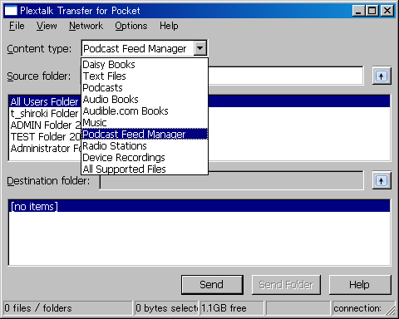

- Select Destination folder list. Go to ‘File’ on the Menu and select ‘New Podcast Feed’.
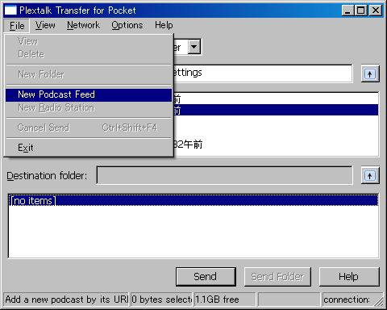

- Input the URL of the podcast feed. For your testing, you can use a sample podcast on the PLEXTALK web site. Please input ‘http://www.plextalk.com/in/rss.xml’ and press the ‘OK’ button.
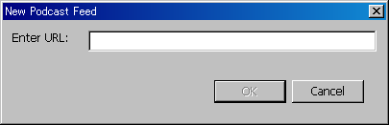

- The name of the podcast feed will appear on the ‘Destination’ list. If you are testing using the sample podcast on the PLEXTALK web site, the name ‘Plextalk Podcast Test’ will appear.
- Disconnect your Linio Pocket from your computer. Exit the software.

Configure network setting of your Linio Pocket

Note: First obtain the information of your home wireless system or an office wireless system from your IT department.

- Enable the network device on your PLEXTALK Linio Pocket. First press the Menu Key and go to “System settings”- “Network settings”- “Enable or disable network device” option. Select ‘Enable’ by the Right or Left Key and press the Down Key. The menu will automatically close when the network device becomes enabled.
Note: If your Linio Pocket is already configured for your network, it will automatically connect. Skip to section 4.
- Search available networks around your Linio Pocket. First press the Menu Key and go to “System settings”- “Network settings”- “Wireless network settings” – “Available wireless network” option. When you press the Down Key, your Linio Pocket will start searching.
- When available networks are listed, select the wireless network you want to connect to If not configured for your selected network, follow steps 4 and 5.
- Input network configurations. Your Linio Pocket will ask you for Security mode, Password, Stealth setting, DHCP and IP address, and Proxy server.
Note: You have an option to configure those network settings using the “Network Configuration” tab of the “PLEXTALK Transfer” software. For more information, see the ”Help” option of the software.

Security mode: | Select the security mode that is set on the access point of the network.
Password: | Input the password, pass phrase or WEP key that is set on the access point of the network.
Stealth setting: | Select OFF.  When your wireless network uses stealth function, select "ON".
DHCP and IP address: | Select ‘Enable’.  If the network does not provide DHCP service, select ‘Disable’ and input an IP address information.
Proxy server: | Select ‘Disable’.  If the network is using a proxy server, select ‘Enable’ and input information on the proxy server.

- When all configurations are finished, your Linio Pocket will try to connect to the network.
- Wait until your Linio Pocket completes the connection. The menu will automatically close when it succeeds.

Download and play your podcast

- Select the podcast feed you want to listen to. First press the Title Key and press the Up Key twice to select “category”. Go to the ‘podcast’ category by using the Right or Left Keys. Then press the Down Key twice to select a title. Select the podcast feed using the Right or Left Keys and press the Play/Stop Key.
- If you hear a voice guide “No episode list. Update the episode list. Are you sure?”, press the Play/Stop Key or # Key to update the episode list.
- When an Episode list is updated, you can select an episode.
- When you select an episode and press the Play/Stop Key, you will hear a voice guide ”This episode has not downloaded yet. Would you like to download?”. When you press the Play/Stop Key, your Linio Pocket will start to download that episode. The episode will be stored on the SD card in your PLEXTALK Linio Pocket.
- You can check the progress of downloading by pressing the 5 Key.
- After your Linio Pocket finishes downloading, you can play the episode by pressing the Play/Stop Key.

Note: The voice guide “No episode list. Update the episode list. Are you sure?” appears only when you play the podcast for the first time.

Reference: Menu items related to Podcast Receiver

In the menu system that appears when you press the Menu Key, there are several items related to the Podcast Receiver function.

“Podcast” menu:
- Update the episode list: Your Linio Pocket will update the podcast episode list.
- Download all episodes of the feed: You can download all the episodes in one podcast feed.

“Media management” menu:
- Delete the selected title: You can delete all the episodes in one podcast feed.
- Delete the file: You can delete the podcast episode you have selected now.

For more information, please see the PLEXTALK Linio Pocket User’s Guide.

End of Tutorial

