PLEXTALK Linio Pocket Tutorial
- Web Radio Streaming -

Shinano Kenshi Co., Ltd. has the right to change the content on this tutorial without prior notice.

Table of Contents

1 What you can do with the Web Radio Streaming function 1
2 Register web radio stations using your computer 1
3 Configure network setting of your Linio Pocket 3
4 Listen to web radio 4

What you can do with the Web Radio Streaming function

By using the Web Radio Streaming function, your PLEXTALK Linio Pocket can play streaming of web radio stations on the Internet.
You will need to register web radio stations on an SD card using your computer.

Register web radio stations using your computer

- Please make sure that your computer is connected to the Internet.
- If not already installed, download the ‘PLEXTALK Transfer’ software from the PLEXTALK web site and install it on your computer.
- Run the ‘PLEXTALK Transfer’ software.
- Download a play list of the web radio station you want to stream on the Internet. For your testing, you can use a sample play list on the PLEXTALK web site. Download http://www.plextalk.com/in/PlextalkWebRadioTest.pls and save it on to your computer.
- Connect your Linio Pocket to your computer via USB. The ‘PLEXTALK Transfer’ will identify your Linio Pocket.
- Select ‘Radio Stations’ on the ‘Content type’ drop down box.
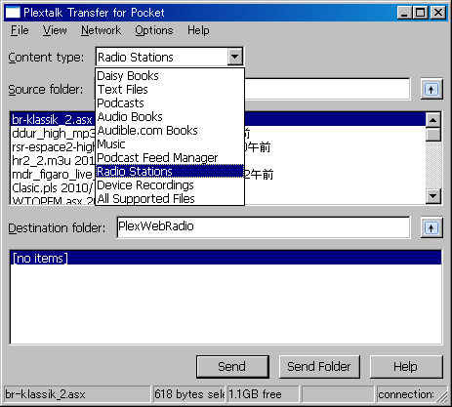

- In the ‘Source folder’ box, select the folder where you have saved the play list at the Step 4.
- Select the play list file you have downloaded and saved at the Step 4, and press the ‘Send’ button. The software will start to transfer the play list to the SD card in your PLEXTALK Linio Pocket.
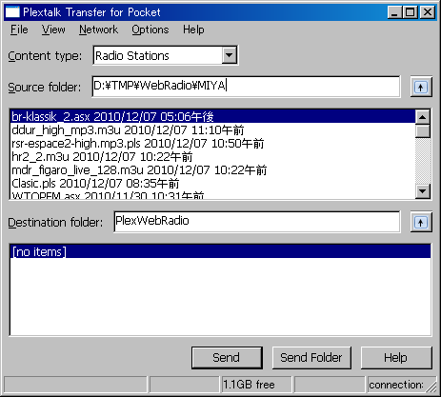

- When finishing the transfer, the name of the play list will appear on the ‘Destination folder’ box.
- Disconnect your Linio Pocket from your computer. Exit the software.

Configure network setting of your Linio Pocket

Note: First obtain the information of your home wireless system or an office wireless system from your IT department.

- Enable the network device on your Linio Pocket. First press the Menu Key and go to “System settings”- “Network settings”- “Enable or disable network device” option. Select ‘Enable’ by the Right or Left Key and press the Down Key. The menu will automatically close when the network device becomes enabled.
Note: If your Linio Pocket is already configured for your network, it will automatically connect. Skip to section 4.
- Search available networks around your Linio Pocket. First press the Menu Key and go to “System settings”- “Network settings”- “Wireless network settings” – “Available wireless network” option. When you press the Down Key, your Linio Pocket will start searching.
- When available networks are listed, select the wireless network you want to connect to If not configured for your selected network, follow steps 4 and 5.
- Input network configurations. Your Linio Pocket will ask you for Security mode, Password, Stealth setting, DHCP and IP address, and Proxy server.
Note: You have an option to configure those network settings using the “Network Configuration” tab of the “PLEXTALK Transfer” software. For more information, see the ”Help” option of the software.

Security mode: | Select the security mode that is set on the access point of the network.
Password: | Input the password, pass phrase or WEP key that is set on the access point of the network.
Stealth setting: | Select OFF.  When your wireless network uses stealth function, select "ON".
DHCP and IP address: | Select ‘Enable’.  If the network does not provide DHCP service, select ‘Disable’ and input an IP address information.
Proxy server: | Select ‘Disable’.  If the network is using a proxy server, select ‘Enable’ and input information on the proxy server.

- When all configurations are finished, your Linio Pocket will try to connect to the network.
- Wait until your Linio Pocket completes the connection. The menu will automatically close when it succeeds.

Listen to web radio

- Select the web radio station you want to listen to. First press the Title Key and press the Up Key twice to select “category”. Go to the ‘web radio’ category by using the Right or Left Keys. Then press the Down Key twice to select a title. Select the web radio station using the Right or Left Keys and press the Play/Stop Key.
- Your Linio Pocket will start streaming the web radio station.

For more information, please see the PLEXTALK Linio Pocket User’s Guide.

End of Tutorial

