PLEXTALK PTN2 Tutorial
- How to Play Audible.com Books on the PTN2-

Shinano Kenshi Co., Ltd. has the right to change the content on this tutorial without prior notice.

Table of Contents

1 Install and set up the Audible Manager
2 Transfer a book to an SD card on the Audible Manager
3 Play the book on the PTN2

Install and set up the Audible Manager

- 1. Get and run the installer of the Audible Manager at http://download.audible.com/AM50/ActiveSetupN.exe or go to http://www.audible.com/sh and select “MP3 Player Software (All non-ipod mp3 players)”
Note: If you are already using the Audible Manager, please update it to the latest version. (Versions V5.5.0.5 or later supports the PTN2.)
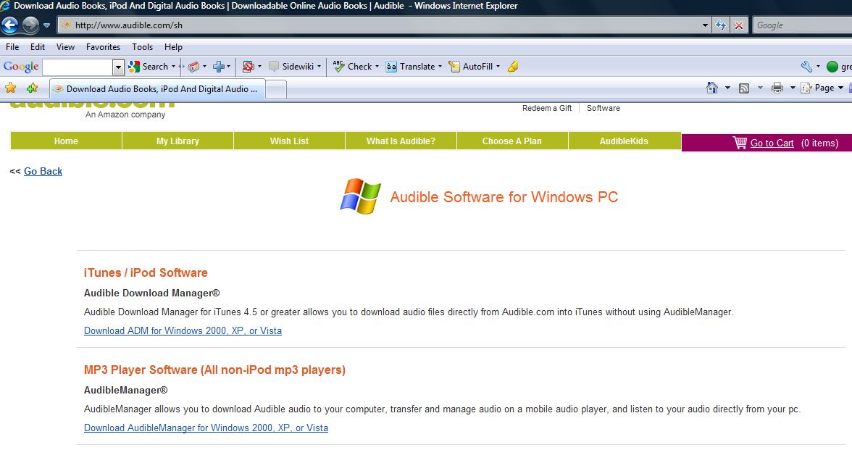

- After the installation, run the Audible Manager. From the ‘Devices’ menu, choose “Add New Device...” and select “Plextalk Devices”.
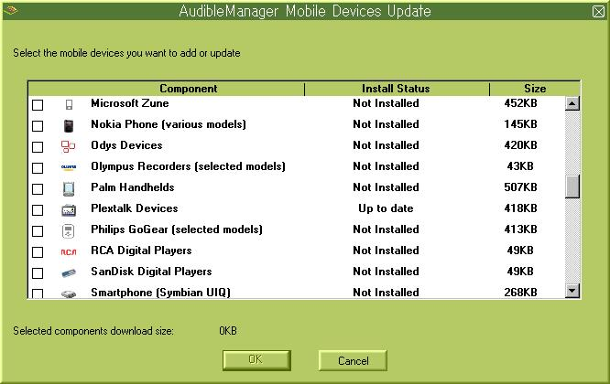

- The Audible Manager will update and then close. Restart the application.

Transfer a book to an SD card on the Audible Manager

- Insert a blank SD card into a card reader connecting to your PC. If your PC has an SD card slot, insert the SD card into the slot. The SD card will be detected as “PlexTalk (SD card)” device.
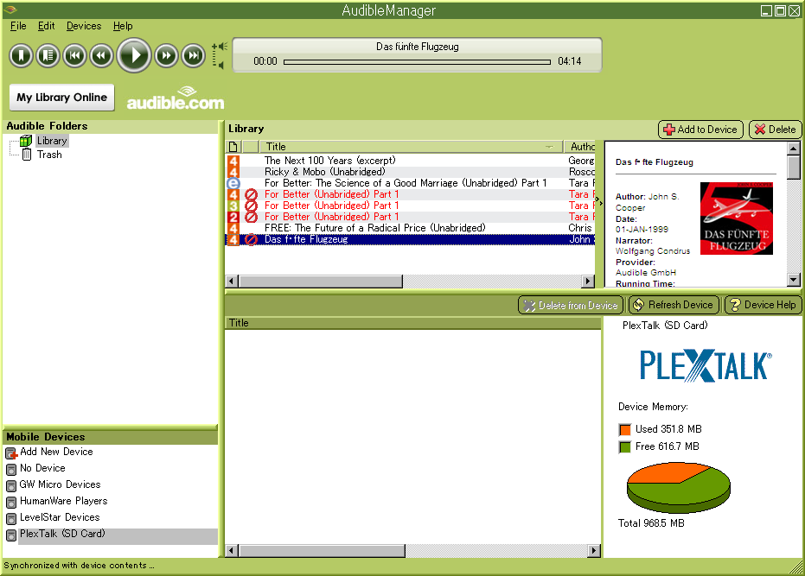
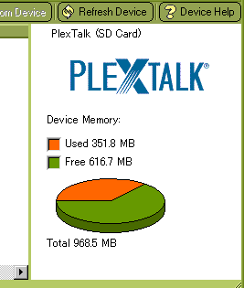

- From the ‘Devices’ menu, select “Activate...”.
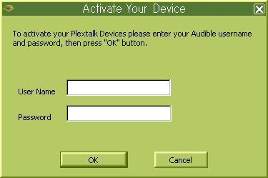

- The information should auto-populate from your Audible.com login. Press the ‘OK’ button.
- Input the serial number of your PTN2.
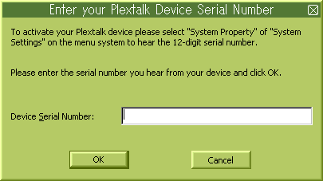
- Transfer a book from Audible.com to the SD card on the Audible Manager software.

Play the book on the PTN2

- Remove the SD card from your PC or the card reader and insert it into the PTN2. The PTN2 will automatically detect the SD card and you will hear the voice ‘SD card, audio book’ then the name of the Audible.com book you have transferred.
- Press the Play/Stop Key to start to play it.
If you have transferred multiple books, press the right or left arrow of the Title Key to select a book then press the Play/Stop Key to start to play it.

NOTE: The PTN2 firmware version must be V3.00.00 or later. You can check the version in the Menu. Press the Menu Key and choose “System Settings” then “System Properties”. The updater is available at: the ‘Support’ page of the PLEXTALK web site.

End of Tutorial

